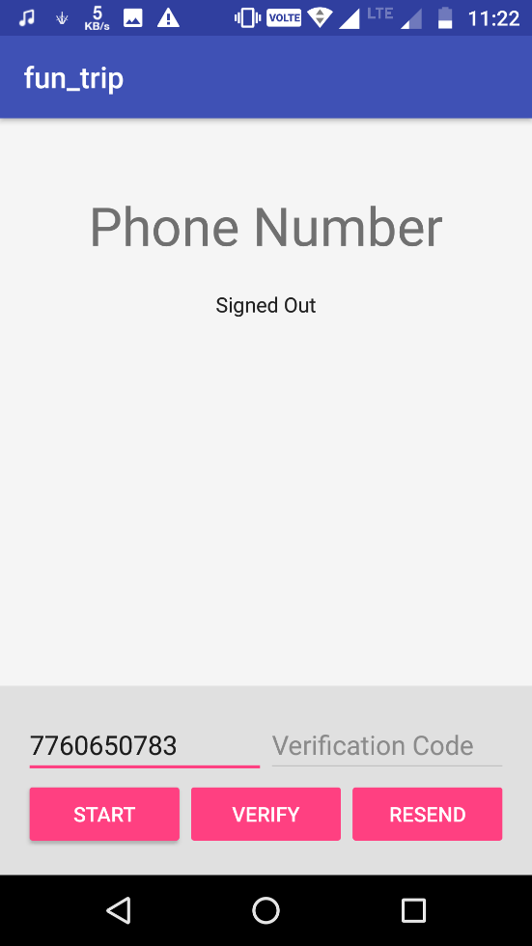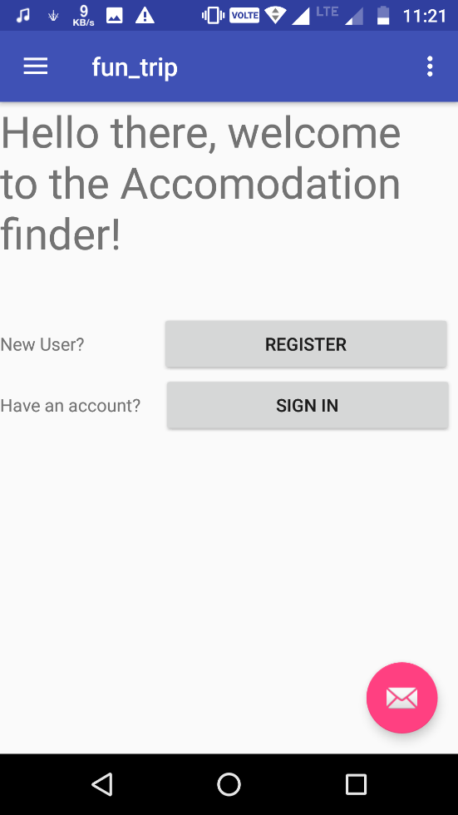

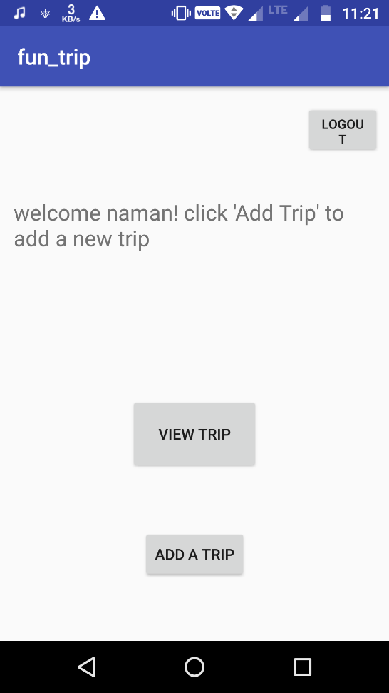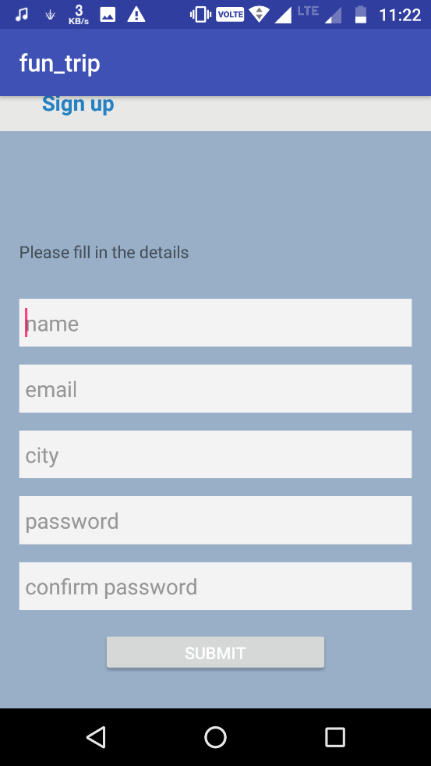

HomeScreen 🡪

Registration 🡪

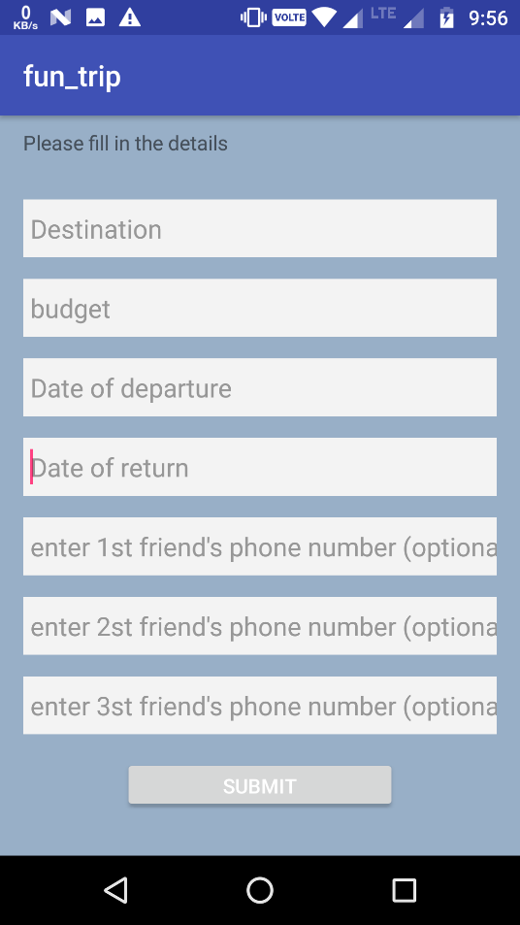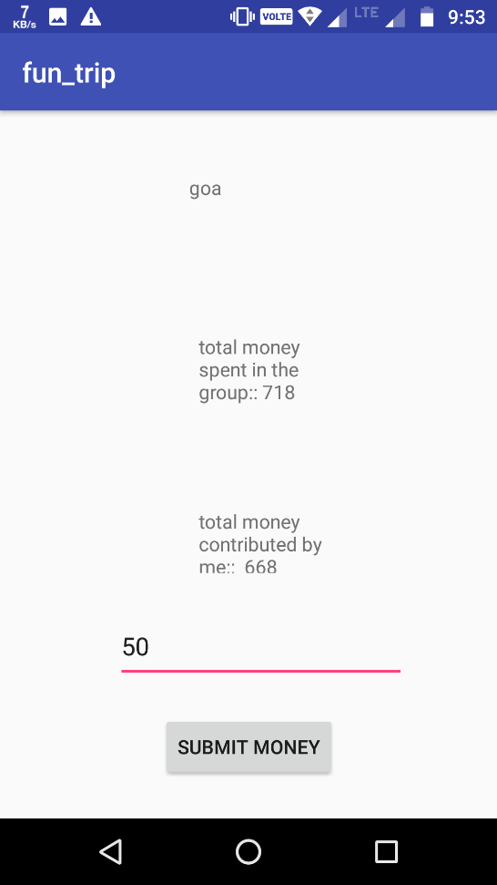

View Trip 🡪

Here, multiple people can manage the money spent in a trip. Each user can push the money spent by him. Which will get saved in the firebase.

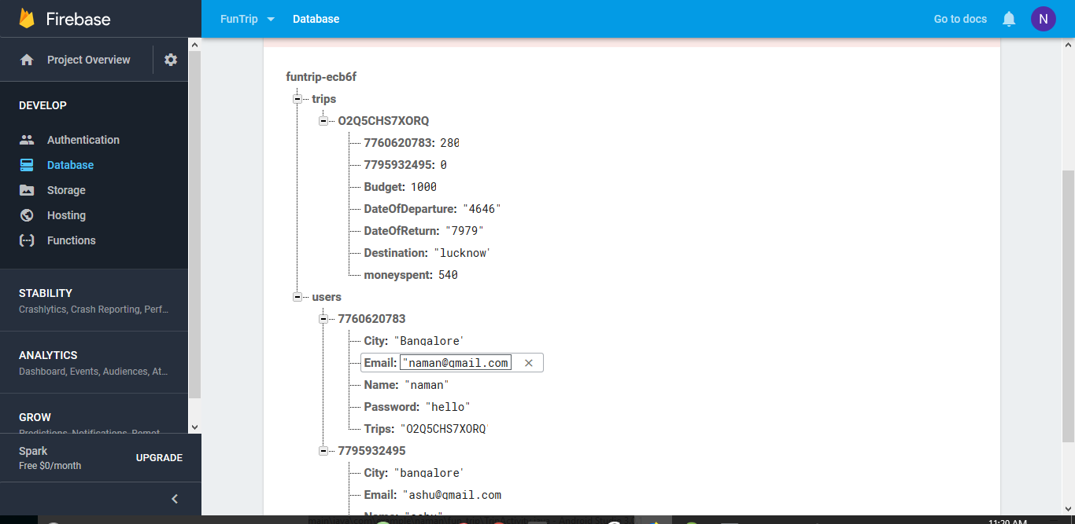

Creating a new Trip 🡪

Here, we can add our friend’s phone number and the trip will get added to that friend’s account.

Everyone will be able to access the same trip

Firebase structure

**Description**

This app will make it easy to manage trips with friends. We can just push in the money spent by a person and it will calculate everyone’s share after the trip.

The app is mainly targeted towards the college students and youngsters. But, anyone can use it.

I have used firebase for database.

**Improvement**

I thought of adding many other features like, using location API I can get the current location and calculate the distance to the destination. I can estimate the time it will take to reach there. I can also build a recommendation system which will suggest the hotels and popular places in the destination.

There can be a lot of improvement in UI. Because of a very busy semester and constraint of time I couldn’t add all those features.

We couldn’t complete it so, we did one extensions of workshop also. For which we have added screenshots below.